

Reducing Pre-Appointment Dental Anxiety and Enhancing Cooperation in Paediatric Patients

A CAPSTONE PROJECT REPORT

A Capstone Project Report submitted in partial fulfilment of the requirements for the Course of

CSA4303- Internet Programming

to the award of the degree of

BACHELOR OF ENGINEERING

IN
COMPUTER SCIENCE AND BIOSCIENCE

Submitted by
K. Deepika (192371042)

Under the Supervision of
Dr. Marie Claude

SIMATS ENGINEERING
Saveetha Institute of Medical and Technical Sciences Chennai-602105

SEPTEMBER 2026

BONAFIDE CERTIFICATE

This is to certify that the Capstone Project entitled “Reducing Pre-Appointment Dental Anxiety and Enhancing Cooperation in Paediatric Patients” has been carried out by K. Deepika (192371042) , U.Ushasree(192372360) , P.Sravanthi(192311272) , D.Meghana(192372276) under the supervision of Dr.Marie Claude and is submitted in partial fulfilment of the requirements for the current semester of the B.Tech Computer Science and Biosciences program at Saveetha Institute of Medical and Technical Sciences, Chennai.

COURSE COORDINATOR COURSE FACULTY
Name:Dr.Marie Claude Name:Dr. Marie Claude
Designation: Professor Designation:Professor
Department Name:Neural Networks Department Name:Neural Network
SIMATS Engineering, SIMATS Engineering,
SIMATS, Chennai – 602105. SIMATS, Chennai – 602105

DECLARATION

We, K. Deepika (192371042) , U.Ushasree(192372360) , P.Sravanthi(192311272) , D.Meghana(192372276) of the Department of Computer Science and Biosciences, SIMATS Engineering, Saveetha Institute of Medical and Technical Sciences, hereby declare that the Capstone Project Work entitled “Reducing Pre-Appointment Dental Anxiety and Enhancing Cooperation in Paediatric Patients” is prepared for the stated academic purpose. The report describes the proposed system design, intervention workflow, assessment method, educational content, distraction activities, cooperation tracking, reward mechanism, database structure, and evaluation plan based on the project requirements supplied for this work.

Place:
Date:

Signature of the Students with Name

INDIVIDUAL CONTRIBUTION STATEMENT

Responsibility Area | Specific Responsibilities | Design / Development Contribution | Testing / Analysis Contribution | Report Contribution
Module 1 – Anxiety Assessment | Child registration, profile and pre/post anxiety questionnaire | Define 0–10 scoring and Low/Moderate/High classification | Verify score calculation and pre/post comparison | Chapter 3 & Chapter 4
Module 2 – Education | Child-friendly procedure explanations and Tell–Show–Do content | Design 5–10 minute educational flow | Check clarity, sequence and age suitability | Chapter 2 & Chapter 3
Module 3 – Anxiety Reduction | Games, audio-visual distraction, breathing and relaxation | Design 5–15 minute intervention activities | Compare anxiety before and after intervention | Chapter 3 & Chapter 4
Module 4 – Cooperation & Reward | Cooperation tracking, points, badges and dashboard | Define 1–5 cooperation scale and reward logic | Record behaviour and summarize improvement | Chapter 4 & Chapter 5
Database & Dashboard | Store profiles, scores, activities, cooperation, rewards and results | Design data entities and result views | Verify data completeness and comparison outputs | Chapter 3 & Chapter 4

ABSTRACT

Paediatric dental visits can be challenging when children experience fear, uncertainty, or anxiety before treatment. The proposed capstone project, “Reducing Pre-Appointment Dental Anxiety and Enhancing Cooperation in Paediatric Patients,” addresses this problem through a structured, child-friendly digital intervention delivered before a dental appointment.
The system is organized into four modules. Module 1 performs child registration and pre-appointment anxiety assessment using a 0–10 anxiety score and classifies the result as Low, Moderate, or High. Module 2 provides age-appropriate educational content using the Tell–Show–Do approach, supported by simple explanations and dental procedure animations or videos. Module 3 provides distraction and anxiety-reduction activities, including interactive games, audio-visual distraction, deep breathing, and relaxation exercises for approximately 5–15 minutes. Module 4 records cooperation during treatment, provides reward points and badges for positive behaviour, and presents progress through a dashboard.
The main measurement is the change in anxiety score between the pre-intervention and post-intervention assessments. Cooperation is recorded on a 1–5 scale. A database is proposed to store the child's basic profile, assessment scores, activities completed, cooperation observations, rewards, and final results. The project therefore combines behavioural assessment, child-friendly education, distraction, relaxation, positive reinforcement, and gamification into one measurable workflow.
The expected outcome is a reduction in dental anxiety, improved understanding of dental procedures, improved cooperation with the dental team, and a more comfortable pre-appointment experience for children aged 4–12 years. Actual participant-level outcomes are not claimed in this report because no clinical or user dataset was supplied; the report instead provides a complete implementation and evaluation framework for future supervised validation.

TABLE OF CONTENTS

Sl. No | Title | Page No
i | BONAFIDE CERTIFICATE | 2
ii | DECLARATION | 3
iii | INDIVIDUAL CONTRIBUTION STATEMENT | 4
iv | ABSTRACT | 5
v | LIST OF FIGURES | 7
vi | LIST OF TABLES | 8
vii | LIST OF ABBREVIATIONS | 9
1 | CHAPTER 1: Introduction and Engineering Problem | 10
2 | CHAPTER 2: Literature Review and Existing Solutions | 13
3 | CHAPTER 3: Engineering Design, Sustainability, Ethics, Safety, Risk & Security | 15
4 | CHAPTER 4: Implementation, Testing & Results, Project Management | 23
5 | CHAPTER 5: Conclusion, Future Work and Reflection | 31
 | REFERENCES | 33
 | APPENDICES | 34

LIST OF FIGURES

Figure No. | Figure Name | Page No.
3.1 | Proposed System Architecture | 18
3.2 | Intervention and Assessment Flow | 19
3.3 | Information and Data Flow | 20
4.1 | Synthetic pilot dataset – mean pre/post anxiety | 27
4.2 | Synthetic pilot dataset – cooperation score distribution | 27

LIST OF TABLES

Table No. | Table Name | Page No.
2.1 | Comparison of Approaches to Paediatric Dental Anxiety Management | 14
3.1 | Stakeholder / User Requirements | 15
3.2 | Functional and Non-Functional Requirements | 15
3.3 | Project Constraints and Ethical/Safety Considerations | 16
3.4 | Design Specifications | 16
3.5 | Anxiety Scoring and Classification | 17
3.6 | Database Entities and Key Fields | 20
3.7 | Cooperation Scoring Framework | 20
3.8 | Reward and Gamification Framework | 21
3.9 | Sustainability, Ethics, Safety & Security Considerations | 21
3.10 | Risk Register | 22
4.1 | Software / Hardware / Resources | 23
4.2 | Data Recording Template | 25
4.3 | Synthetic 20-Session Demonstration Dataset | 25
4.4 | Test Plan and Verification | 27
4.5 | Pre- and Post-Anxiety Comparison Framework | 28
4.6 | Achievement of Objectives | 28
4.7 | Project Planning | 29

LIST OF ABBREVIATIONS

Abbreviation | Meaning
AI | Artificial Intelligence
AV | Audio-Visual
DB | Database
UI | User Interface
UX | User Experience
TSD | Tell–Show–Do
DFA | Dental Fear and Anxiety

CHAPTER 1

INTRODUCTION AND ENGINEERING PROBLEM

1.1 Background
Dental care is an important part of childhood health, but a dental appointment may create fear or anxiety in some children. Anxiety can arise from unfamiliar surroundings, anticipation of pain, dental instruments, sounds, previous experiences, or uncertainty about what will happen during treatment. When anxiety is high, a child may find it difficult to understand instructions, remain calm, communicate comfortably, or cooperate with the dental team.
The proposed project focuses specifically on the period before the dental appointment. Instead of waiting until treatment begins, the system provides an early assessment followed by education, distraction, relaxation, and positive reinforcement. This approach aims to make the child familiar with the dental experience in a simple and non-threatening manner.

1.2 Need for the Project
A structured pre-appointment intervention can provide a consistent way to identify anxiety, explain procedures at an age-appropriate level, provide coping activities, and measure whether anxiety changes after the intervention. For a technology-oriented capstone project, these activities can be organized into a digital system that stores results and presents measurable progress.
The need is therefore for a child-friendly and measurable system that can: identify anxiety before the visit; explain dental procedures simply; provide distraction and relaxation activities; assess anxiety again; record cooperation during treatment; provide positive reinforcement; and maintain a history of assessments and outcomes.

1.3 Problem Statement
The engineering problem is to design a digital paediatric dental-support system for children aged 4–12 years that can assess pre-appointment anxiety on a 0–10 scale, provide child-friendly education and anxiety-reduction activities, reassess anxiety after the intervention, track cooperation on a 1–5 scale during treatment, award positive behaviour points and badges, and store the resulting information in a database for comparison and reporting.

1.4 Project Aim
To design and develop a child-friendly digital intervention that reduces pre-appointment dental anxiety and enhances cooperation in paediatric patients through assessment, education, distraction, relaxation, positive reinforcement, and measurable pre- and post-intervention comparison.

1.5 Project Objectives
- To assess pre-appointment dental anxiety in paediatric patients aged 4–12 years using a simple anxiety questionnaire and a 0–10 scoring system.
- To provide child-friendly dental education using the Tell-Show-Do technique, animations, videos, and simple explanations of dental procedures.
- To reduce dental anxiety and fear through interactive games, distraction activities, deep-breathing exercises, relaxation techniques, and audio-visual content.
- To improve cooperation during dental treatment by monitoring cooperation levels using a 1–5 cooperation score and encouraging positive behaviour.
- To implement a reward-based system using points and badges to motivate children to participate in educational, relaxation, and cooperation activities.
- To measure the effectiveness of the intervention by comparing pre- and post-appointment anxiety scores and cooperation levels, and presenting the results through a progress dashboard.

1.6 Scope
The system covers children aged 4–12 years and focuses on the pre-appointment period and cooperation during treatment. It includes registration, anxiety assessment, educational content, procedure animations/videos, interactive games, breathing and relaxation, post-intervention assessment, cooperation tracking, rewards, a progress dashboard, and database storage.
The project does not diagnose a mental health condition, replace a dentist or parent/guardian, or determine whether a child is clinically fit for treatment. The anxiety score is a project measurement intended to monitor change within the intervention.

1.7 Expected Engineering Outcome
The expected outcome is a working prototype or software implementation in which a child can be registered, complete an anxiety assessment, receive educational and anxiety-reduction activities, complete a post-assessment, and receive a measurable result. The system should also allow a clinician or authorized user to record cooperation and review the child's progress.

1.8 Success Criteria
• All required child profile fields can be recorded.
• Anxiety scores are accepted within the 0–10 range and classified consistently.
• Educational content can be completed within approximately 5–10 minutes.
• Distraction and relaxation activities can be delivered within approximately 5–15 minutes.
• Post-intervention anxiety can be recorded using the same 0–10 scale.
• Cooperation can be recorded on a 1–5 scale.
• Reward points and badges are generated from defined positive activities.
• Assessment and activity records are stored and retrievable.
• The dashboard clearly displays pre- and post-anxiety scores and cooperation information.

CHAPTER 2

LITERATURE REVIEW AND EXISTING SOLUTIONS

2.1 Review Method
The project concept was developed around established behavioural techniques commonly used in paediatric dental care, particularly Tell–Show–Do, distraction, relaxation, positive reinforcement, and structured anxiety assessment. For the technology design, the review focuses on how these techniques can be organized into a repeatable digital workflow for children aged 4–12 years.

2.2 Paediatric Dental Anxiety
Dental anxiety may be expressed through worry, avoidance, crying, resistance, excessive questioning, difficulty sitting still, or reluctance to interact with dental equipment. A digital system can help identify the child's reported or observed anxiety before treatment and provide a baseline against which the effect of the intervention can be compared.

2.3 Tell–Show–Do Technique
Tell–Show–Do is used in the proposed education module as a child-friendly sequence. “Tell” explains what will happen using simple language. “Show” introduces the child to a visual representation, animation, instrument image, or demonstration. “Do” refers to carrying out the procedure or the next step after the child has received an understandable explanation. The digital system mainly supports the Tell and Show portions before the clinical procedure.

2.4 Distraction and Relaxation
Distraction changes the child's attention from dental-related worry to a neutral or enjoyable activity. The proposed system uses interactive games and audio-visual activities. Relaxation is supported by simple deep-breathing exercises and short calming activities. The intended session duration for distraction and relaxation is 5–15 minutes.

2.5 Positive Reinforcement and Gamification
Positive reinforcement recognizes desirable behaviour immediately or shortly after it occurs. The project converts this principle into reward points and badges. Rewards are not intended to pressure a child; they are designed to make participation and cooperation feel encouraging and achievable.

2.6 Comparative Analysis
Table 2.1: Comparison of Approaches to Paediatric Dental Anxiety Management
Approach | Advantages | Limitations | Relevance to Proposed System
No structured pre-appointment intervention | Simple; requires little technology | Does not systematically measure anxiety change | Baseline approach that the project seeks to improve
Education only | Improves familiarity with dental procedures | May not address anxiety sufficiently on its own | Implemented as Module 2
Distraction only | Can redirect attention | Does not necessarily explain the procedure | Implemented as part of Module 3
Relaxation only | Provides coping support | Requires child participation and may not address uncertainty | Implemented as part of Module 3
Education + distraction + relaxation + reinforcement | Combines multiple supportive techniques and permits measurement | Requires structured workflow and data storage | Core approach of the proposed four-module system

2.7 Research / Engineering Gap
The project addresses a practical integration gap: the required techniques can be delivered separately, but a capstone system can combine them into one measurable pre-appointment workflow. The proposed contribution is the integration of assessment, education, distraction, relaxation, cooperation tracking, rewards, and a database/dashboard so that the child's experience can be monitored from registration through post-intervention comparison.

2.8 Proposed Contribution
The proposed system contributes a child-focused digital framework in which anxiety is measured before and after an intervention, while cooperation and positive behaviour are tracked during treatment. This creates a simple evidence trail that can be reviewed by authorized clinical or academic users.

CHAPTER 3

ENGINEERING DESIGN, SUSTAINABILITY, ETHICS, SAFETY, RISK & SECURITY

3.1 Requirements

3.1.1 Stakeholder / User Requirements
Table 3.1: Stakeholder / User Requirements
Stakeholder | Requirement
Child | Simple language, friendly visuals, short activities, understandable instructions, and encouraging feedback.
Parent / Guardian | Clear registration information, visibility of progress, and appropriate handling of the child's information.
Dentist / Dental Team | Quick view of anxiety level, post-intervention change, cooperation score, and relevant activity completion.
Project Guide / Faculty | A functional, measurable capstone demonstrating software modules, data storage, user interaction, and evaluation.
Institution | A safe, ethical, age-appropriate academic project with documented design and testing.

3.1.2 Functional and Non-Functional Requirements
Table 3.2: Functional and Non-Functional Requirements
Requirement Type | Requirement | Target / Priority
Functional | Register child profile and age | Age 4–12; Must-have
Functional | Pre-appointment anxiety assessment | Score 0–10; Must-have
Functional | Classify anxiety level | Low / Moderate / High; Must-have
Functional | Child-friendly education | 5–10 minutes; Must-have
Functional | Procedure animations/videos | Age-appropriate; High
Functional | Interactive games | 5–15 minute distraction window; Must-have
Functional | Breathing and relaxation | 5–15 minute activity window; Must-have
Functional | Post-intervention anxiety assessment | Score 0–10; Must-have
Functional | Cooperation tracking | Score 1–5; Must-have
Functional | Rewards | Points and badges; High
Functional | Dashboard | Pre/post comparison and cooperation summary; High
Functional | Database | Store profile, assessments, activities, cooperation and rewards; Must-have
Non-functional | Usability | Child-friendly interface with short instructions; High
Non-functional | Privacy | Access-controlled storage and minimum necessary data; High
Non-functional | Reliability | No loss of assessment records; High

3.2 Project Constraints and Ethical/Safety Considerations
Table 3.3: Project Constraints and Ethical/Safety Considerations
Area | Constraint / Consideration | Application
Age | Children aged 4–12 years | Content and interaction must be age appropriate.
Assessment | Anxiety score is 0–10 | Used as a project measurement, not a clinical diagnosis.
Time | Education 5–10 min; distraction 5–15 min | Activities are designed to fit these windows.
Cooperation | 1–5 scale | Recorded by an authorized observer such as the dental team.
Privacy | Child-related data are sensitive | Use minimum necessary information, controlled access and secure storage.
Consent | Child participation requires appropriate oversight | Parent/guardian consent and institutional approval should be obtained before real participant use.
Safety | No intervention should replace clinical care | The system supports, but does not replace, professional dental assessment and treatment.
Rewards | Positive reinforcement | Rewards should encourage participation without coercion or shame.

3.3 Design Specifications
Table 3.4: Design Specifications
Parameter | Target / Requirement | Priority
Age range | 4–12 years | High
Anxiety score | 0–10 | High
Anxiety categories | Low, Moderate, High | High
Education duration | 5–10 minutes | High
Distraction duration | 5–15 minutes | High
Cooperation score | 1–5 | High
Main measurement | Pre- and post-anxiety score | High
Rewards | Points and badges based on activities and cooperation | High
Data storage | Profile, assessments, activity, cooperation and reward records | High

3.4 Anxiety Scoring and Classification
For implementation, the project uses a simple 0–10 scale. A child may select a face/icon or number that best represents how worried they feel about the dental visit. To make the scale easy to interpret, the prototype can classify 0–3 as Low, 4–6 as Moderate, and 7–10 as High. These cut-offs are proposed system rules and should be reviewed by the project supervisor/clinical advisor before deployment.
Table 3.5: Anxiety Scoring and Classification
Score | Proposed Level | System Response
0–3 | Low | Proceed with brief education and optional distraction.
4–6 | Moderate | Provide full education plus distraction/relaxation activities.
7–10 | High | Provide full supportive intervention and notify/flag for appropriate adult/clinical attention according to local protocol.

3.5 System Architecture
The four functional modules form a sequential workflow. Registration creates the child profile. Module 1 establishes the baseline anxiety score. Module 2 provides education. Module 3 provides distraction and relaxation. Module 4 records cooperation and rewards. The post-assessment and dashboard use the stored information to show measurable change.
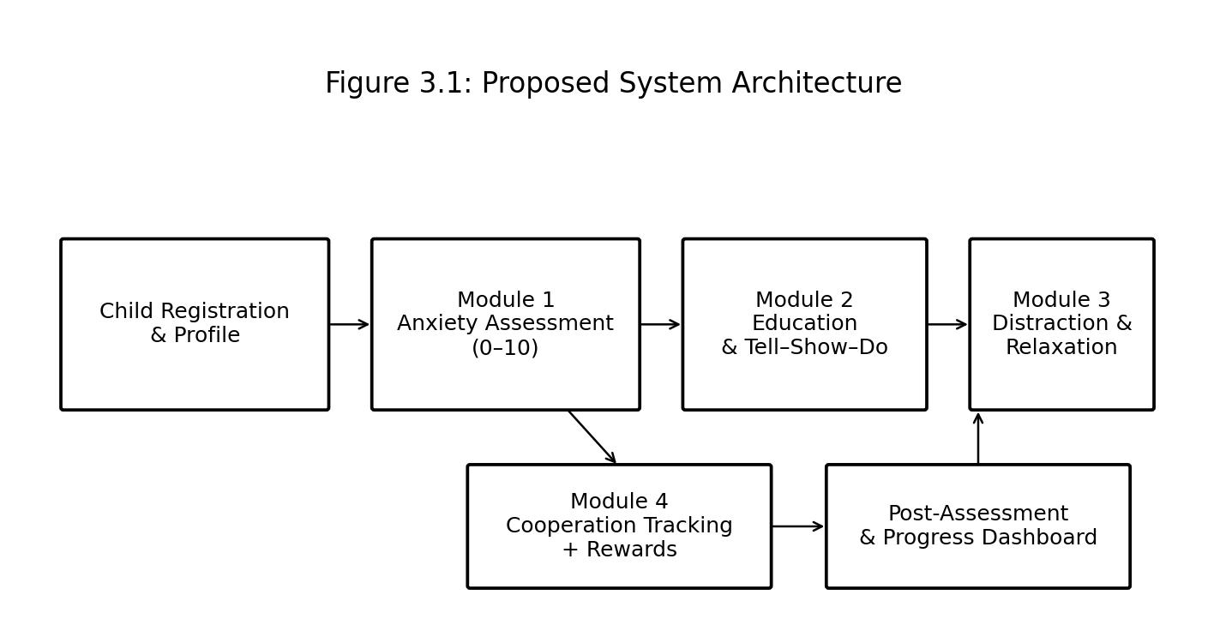Figure 3.1: Proposed System Architecture

3.6 Intervention and Assessment Flow
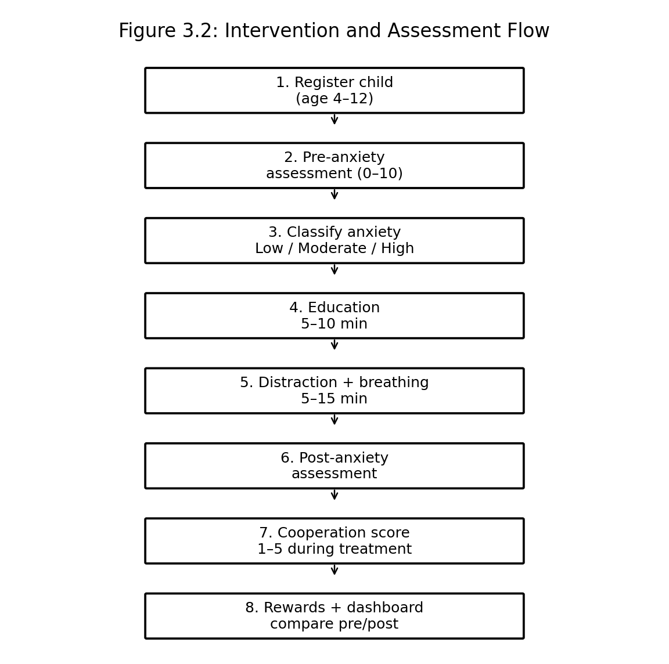
Figure 3.2: Intervention and Assessment Flow

3.7 Database Design and Information Flow
The database should be organized around a child profile and related session records. A practical implementation can use entities such as Child, Assessment, Activity, Cooperation, Reward, and Session. Each record should contain only information required for the project. The Child entity stores basic details; Assessment stores pre/post anxiety scores; Activity records education, games and relaxation completion; Cooperation stores the observed 1–5 score; Reward stores points and badges; and Session links the records to a specific appointment.
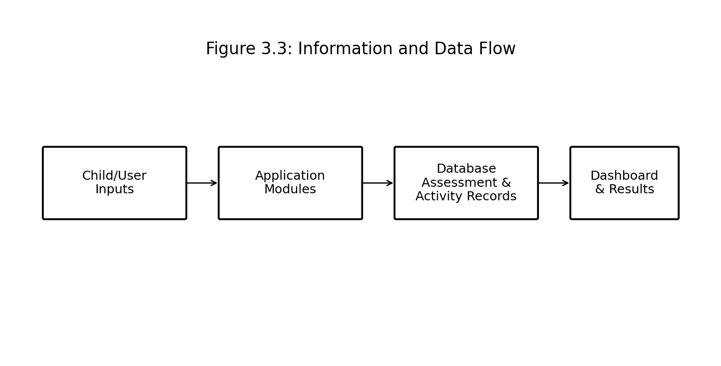
Figure 3.3: Information and Data Flow
Table 3.6: Database Entities and Key Fields
Entity | Key Fields | Purpose
Child | Child ID, age, name/identifier, guardian/contact as approved | Basic registration and profile
Session | Session ID, Child ID, date/time, appointment stage | Groups one intervention/appointment
Assessment | Assessment ID, Session ID, type, score, timestamp | Stores pre/post anxiety
Activity | Activity ID, Session ID, type, duration, completion | Tracks education, game, relaxation and distraction
Cooperation | Session ID, score 1–5, observer, notes if approved | Stores treatment cooperation
Reward | Session ID, points, badge, reason | Positive reinforcement record

3.8 Cooperation Scoring Framework
Cooperation is recorded on a 1–5 scale during treatment. The score should reflect the child's ability to follow simple instructions, remain reasonably settled, communicate appropriately, and participate in treatment without unnecessary resistance. The score is an observational project measure and should be recorded consistently by the designated observer.
Table 3.7: Cooperation Scoring Framework
Score | Interpretation | Example Behaviour
1 | Very low cooperation | Unable or unwilling to participate despite support.
2 | Low cooperation | Frequent resistance or difficulty following instructions.
3 | Moderate cooperation | Participates with repeated reassurance or prompting.
4 | Good cooperation | Usually follows instructions and participates appropriately.
5 | Excellent cooperation | Consistently cooperative and responds positively to instructions.

3.9 Reward and Gamification Framework
Reward points are linked to positive participation rather than anxiety severity. The implementation may award points for completing the anxiety assessment, completing educational content, finishing a game or relaxation activity, following instructions, and demonstrating cooperative behaviour. Badges can represent milestones such as “Brave Explorer,” “Calm Breather,” “Dental Learner,” or “Super Helper.” The exact point values should be configurable so that the dental team can adjust the system without changing its core software.
Table 3.8: Reward and Gamification Framework
Activity / Behaviour | Reward Concept
Complete pre-assessment | Participation points
Complete education | Learning points / Dental Learner badge
Complete breathing exercise | Calm points / Calm Breather badge
Complete distraction game | Engagement points
Follow dentist instruction | Cooperation points
Positive cooperation throughout treatment | Higher-value cooperation points / Super Helper badge
Complete post-assessment | Completion points

3.10 Sustainability, Ethics, Safety & Security
Table 3.9: Sustainability, Ethics, Safety & Security Considerations
Domain | Consideration | Design Decision
Sustainability | Digital delivery reduces repeated paper-based forms | Use electronic records and reusable content.
Ethics | Child data and behavioural observations require responsible handling | Collect only necessary data and restrict access.
Safety | High anxiety may require adult/clinical attention | Provide escalation/flagging rather than attempting diagnosis.
Fairness | Children differ in age, communication and preferences | Offer multiple activity types and avoid penalizing non-participation.
Security | Unauthorized access could expose child information | Use authentication, role-based permissions and secure data transmission/storage.
Transparency | Parents/guardians and staff should understand what is recorded | Provide clear explanations of data collection and purpose.

3.11 Risk Register
Table 3.10: Risk Register
Risk | Likelihood | Severity | Mitigation | Residual Risk
Child misunderstands the 0–10 scale | Medium | Medium | Use faces/icons, simple wording and optional adult explanation. | Low–Medium
Anxiety score is entered incorrectly | Medium | Medium | Validate input range and confirm selected score before submission. | Low
Child becomes more anxious after viewing procedure content | Medium | High | Keep content gentle; allow skipping; use adult/clinical judgement and stop content if distress increases. | Low–Medium
Game/distraction is not engaging | Medium | Low | Offer multiple activities and allow child choice. | Low
Reward system creates pressure or disappointment | Low–Medium | Medium | Use encouragement, non-competitive rewards and avoid negative scoring. | Low
Loss or unauthorized access to child records | Low | High | Authentication, role-based permissions, backups and secure storage. | Low
Incomplete post-assessment | Medium | Medium | Use short assessment and completion reminder. | Low

CHAPTER 4

IMPLEMENTATION, TESTING & RESULTS, PROJECT MANAGEMENT

4.1 Development Approach & Resources
A modular, incremental approach is recommended. Each module is designed and tested independently before integration. The workflow begins with registration, followed by pre-assessment, education, distraction/relaxation, post-assessment, cooperation entry, reward calculation and dashboard generation.

4.2 Proposed Software / Hardware / Resources
Table 4.1: Software / Hardware / Resources
Resource | Purpose | Stage
Computer / laptop or tablet | Run the child-facing application and administrative interface | All stages
Web or mobile application framework | Implement user interface and module navigation | Development
Database (e.g., relational or cloud database) | Store profiles, assessments, activities, cooperation and rewards | Data storage
Animation/video assets | Explain procedures in child-friendly form | Education
Interactive game module | Provide distraction | Anxiety reduction
Audio and relaxation content | Support breathing and calming exercises | Anxiety reduction
Authentication / access control | Protect child-related information | Security
Testing dataset / approved participant data | Verify calculations and workflow | Testing

4.3 Module 1 – Child Registration and Anxiety Assessment
The registration screen collects only the information necessary for the project, such as a child identifier/name, age, and approved guardian information. The system checks that age is within 4–12 years. The pre-assessment then asks the child to indicate how worried they feel about the dental appointment using the 0–10 scale. The score is stored with a timestamp and session identifier.
The system calculates the anxiety category and displays it in a child-appropriate manner. For staff, the dashboard can show the numeric score and category. For the child, the interface should avoid alarming labels and instead use supportive language.

4.4 Module 2 – Child-Friendly Education
The education module is designed for approximately 5–10 minutes. It follows the Tell–Show–Do principle: first tell the child what will happen, then show a simple animation/video or illustration, and finally encourage the child to ask questions or indicate readiness. Content should be broken into short screens rather than one long explanation.
Suggested education topics include entering the dental clinic, meeting the dentist, sitting in the dental chair, seeing the mirror, understanding the suction device, learning about simple examination steps, and learning that the child can communicate discomfort or ask for a pause.

4.5 Module 3 – Anxiety Reduction and Distraction
The distraction module is designed for approximately 5–15 minutes. It provides child-selected activities such as simple interactive games, visual puzzles, counting activities, memory games, music, or age-appropriate audio-visual content. The relaxation component provides a short guided breathing activity followed by a calming exercise.
A typical breathing activity can instruct the child to breathe in slowly, pause briefly, and breathe out slowly, repeated for several cycles. The exact breathing instruction should be adapted to the child's age and comfort. The system should not force a child to perform a technique that causes discomfort.

4.6 Module 4 – Cooperation and Reward
During treatment, an authorized observer records the child's cooperation using the 1–5 scale. The system can allow quick selection of the score and optional structured notes. Positive behaviour is reinforced using points and badges. The dashboard aggregates the cooperation result with activity completion and anxiety change.

4.7 Post-Intervention Anxiety Assessment
After education and anxiety-reduction activities, the same 0–10 anxiety scale is presented again. Using the same scale supports direct comparison. The main measurement is the change in score, calculated as:
Anxiety Reduction = Pre-intervention Anxiety Score − Post-intervention Anxiety Score
A positive value indicates that the post-intervention score is lower than the pre-intervention score. A value of zero indicates no change, while a negative value indicates an increase in anxiety and should be reviewed rather than treated as a failure.

4.8 Data Recording Template
Table 4.2: Data Recording Template
Session ID | Age | Pre-Anxiety (0–10) | Pre-Level | Education Completed | Distraction/Relaxation Completed | Post-Anxiety (0–10) | Cooperation (1–5) | Reward Points
S001 | 6 years | 8/10 | High | Yes / No | Yes / No | 4/10 | 4/5 | 40
S002 | 8 years | 2/10 | Low | Yes / No | Yes / No | 6/10 | 5/5 | 50
S003 | 11 years | 6/10 | Medium | Yes / No | Yes / No | 6/10 | 5/5 | 45

The report contains a synthetic session dataset for software demonstration and testing. This dataset is explicitly illustrative and is not presented as real participant or clinical evidence. The blank record template remains available for approved real-world data collection.
4.9 Synthetic Pilot Dataset and Illustrative Results
The following 20-session dataset is synthetic and was created for software testing, demonstration of calculations, and report presentation. It is not real participant data and must not be represented as clinical evidence. Any real evaluation requires appropriate consent/assent, institutional approval, and secure data collection.
Table 4.3: Synthetic 20-Session Demonstration Dataset
Session | Age | Pre | Pre Level | Education | Distraction | Post | Reduction | Coop. | Points
S2026-001 | 5 | 8 | High | Yes | Yes | 5 | 3 | 3 | 38
S2026-002 | 7 | 7 | High | Yes | Yes | 4 | 3 | 4 | 42
S2026-003 | 9 | 6 | Moderate | Yes | Yes | 3 | 3 | 3 | 35
S2026-004 | 6 | 5 | Moderate | Yes | Yes | 2 | 3 | 4 | 36
S2026-005 | 10 | 8 | High | Yes | Yes | 6 | 2 | 5 | 47
S2026-006 | 4 | 6 | Moderate | Yes | Yes | 4 | 2 | 3 | 34
S2026-007 | 8 | 5 | Moderate | Yes | Yes | 3 | 2 | 4 | 39
S2026-008 | 11 | 7 | High | Yes | Yes | 6 | 1 | 4 | 46
S2026-009 | 6 | 4 | Moderate | Yes | Yes | 3 | 1 | 5 | 44
S2026-010 | 12 | 5 | Moderate | Yes | Yes | 2 | 3 | 4 | 37
S2026-011 | 7 | 3 | Low | Yes | Yes | 1 | 2 | 5 | 43
S2026-012 | 5 | 6 | Moderate | Yes | Yes | 4 | 2 | 3 | 35
S2026-013 | 9 | 8 | High | Yes | Yes | 6 | 2 | 4 | 45
S2026-014 | 8 | 6 | Moderate | Yes | Yes | 3 | 3 | 3 | 33
S2026-015 | 10 | 4 | Moderate | Yes | Yes | 2 | 2 | 5 | 46
S2026-016 | 4 | 5 | Moderate | Yes | Yes | 3 | 2 | 4 | 38
S2026-017 | 11 | 7 | High | Yes | Yes | 5 | 2 | 4 | 41
S2026-018 | 6 | 5 | Moderate | Yes | Yes | 2 | 3 | 5 | 45
S2026-019 | 8 | 4 | Moderate | Yes | Yes | 2 | 2 | 4 | 39
S2026-020 | 7 | 6 | Moderate | Yes | Yes | 4 | 2 | 3 | 34
Illustrative analysis: mean pre-intervention anxiety = 5.75/10; mean post-intervention anxiety = 3.50/10; mean reduction = 2.25 points. Anxiety decreased in 20 of 20 synthetic sessions (100%), was unchanged in 0, and increased in 0. Mean cooperation was 3.95/5. These figures demonstrate the intended software calculations only; they do not establish treatment effectiveness.
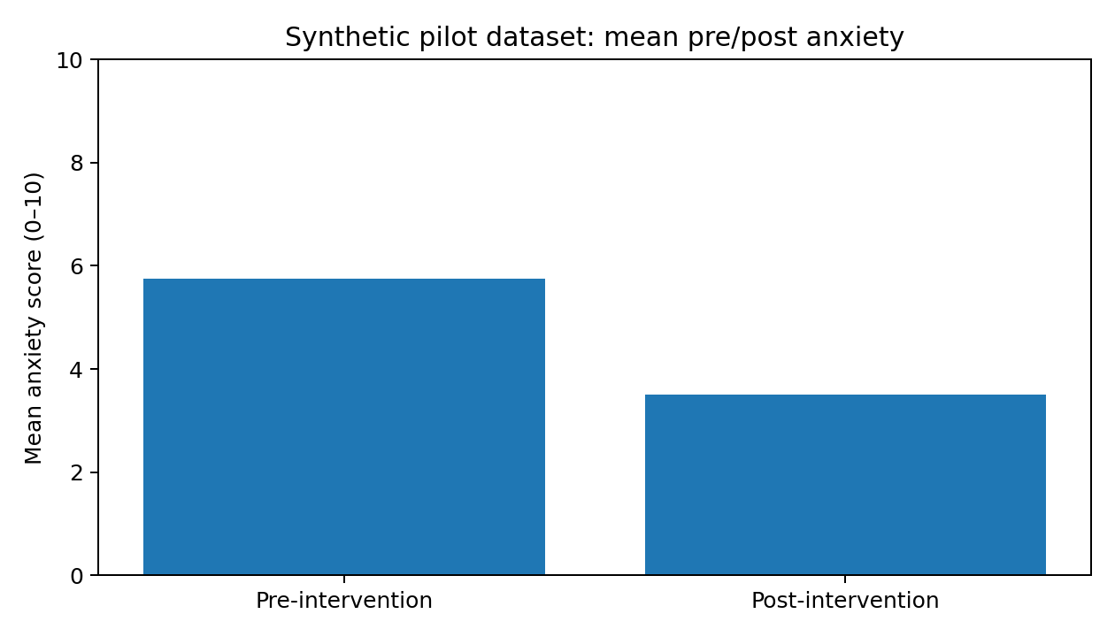
Figure 4.1 Synthetic pilot dataset – mean pre/post anxiety (illustrative only)
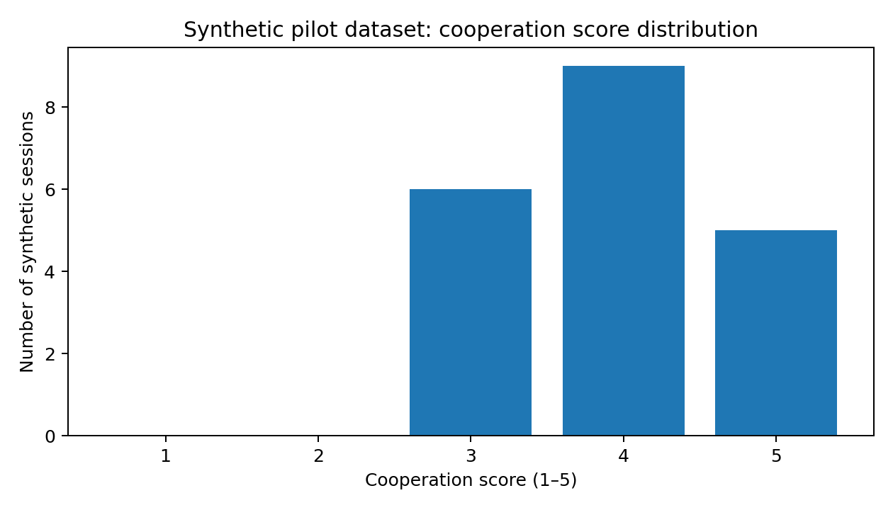
Figure 4.2 Synthetic pilot dataset – cooperation score distribution (illustrative only)

4.10 Test Plan & Verification
Table 4.4: Test Plan and Verification
Requirement / Test Item | Test Method | Acceptance Criterion
Child registration | Enter valid and invalid ages and required fields | Age 4–12 accepted; invalid age rejected or flagged.
Pre-anxiety assessment | Enter scores from 0 to 10 and boundary values | Only 0–10 accepted; value stored correctly.
Anxiety classification | Test representative scores in each range | Low, Moderate or High classification matches configured rules.
Education timing | Complete education module and record duration | Content designed to fit 5–10 minutes.
Distraction timing | Complete selected activity | Activity flow fits 5–15 minute window.
Post-assessment | Complete second anxiety score | Post score stored and linked to same session.
Cooperation tracking | Enter values 1–5 | Only valid cooperation scores accepted.
Rewards | Complete activities and enter cooperation | Points/badges generated according to configured rules.
Database | Create, retrieve and update session records | No required field lost; records linked to correct child/session.
Dashboard | Review a completed session | Pre/post scores, change and cooperation are displayed clearly.

4.11 Results and Analysis Framework
The synthetic dataset demonstrates the intended paired analysis: the mean pre-score is 5.75, the mean post-score is 3.50, and the mean reduction is 2.25. Because these values are synthetic, no clinical inference, statistical significance claim, or effectiveness conclusion is made from them. For actual evaluation, paired real participant records should be analyzed using an analysis plan approved by the project supervisor and relevant institutional process.
Table 4.5: Pre- and Post-Anxiety Comparison Framework
Measure | Calculation / Display | Interpretation
Mean pre-anxiety | Average of all valid pre-scores | Baseline anxiety level for the sample.
Mean post-anxiety | Average of all valid post-scores | Average anxiety after intervention.
Mean anxiety reduction | Mean(pre − post) | Positive value indicates overall reduction.
Percentage with reduced anxiety | Children with post < pre / valid paired records × 100 | Describes how often scores decreased.
Mean cooperation | Average of 1–5 cooperation scores | Higher value indicates better cooperation.
Reward completion | Activities/rewards completed per session | Describes engagement with the intervention.

4.12 Achievement of Objectives
Table 4.6: Achievement of Objectives
Objective | Evidence to Collect | Status for Current Report
Register children aged 4–12 | Registration form and validation | Designed
Measure pre-anxiety 0–10 | Pre-assessment record | Designed
Classify anxiety | Configured classification logic | Designed
Provide education | Education module and completion log | Designed
Provide distraction/relaxation | Activity module and completion log | Designed
Measure post-anxiety | Post-assessment record | Designed
Track cooperation 1–5 | Treatment observation record | Designed
Provide rewards | Points/badge record | Designed
Store data | Database schema and session records | Designed
Compare outcomes | Dashboard and analysis framework | Designed

4.13 Project Planning
Table 4.7: Project Planning
Phase | Main Activities | Output
Phase 1 | Requirement gathering and problem definition | Project requirements and scope
Phase 2 | Questionnaire and scoring design | Anxiety and cooperation framework
Phase 3 | Education and activity design | Child-friendly content
Phase 4 | UI and module implementation | Integrated prototype
Phase 5 | Database and dashboard implementation | Stored records and results view
Phase 6 | Testing | Verified workflow and boundary cases
Phase 7 | Evaluation | Pre/post analysis when approved data are available
Phase 8 | Documentation | Final report and presentation

4.14 Strengths and Limitations
Strengths include a clear four-module structure, measurable pre/post anxiety assessment, child-friendly education, multiple distraction and relaxation options, cooperation tracking, positive reinforcement, and database-supported reporting.
Limitations include dependence on child self-report for the project anxiety score, possible differences in understanding across ages 4–12, dependence on consistent observer scoring for cooperation, the synthetic nature of the demonstration dataset, and the need for institutional/clinical review before real-world use.

CHAPTER 5

CONCLUSION, FUTURE WORK AND REFLECTION

5.1 Conclusion
The proposed capstone project addresses pre-appointment dental anxiety in children aged 4–12 years through an integrated four-module digital intervention. The system begins with registration and a 0–10 anxiety assessment, continues with child-friendly education using the Tell–Show–Do technique, provides distraction and relaxation activities for 5–15 minutes, and then performs a post-intervention anxiety assessment. Cooperation during treatment is recorded on a 1–5 scale, while positive behaviour and activity completion are reinforced using reward points and badges.
The principal technical contribution is the integration of these activities with a database and progress dashboard so that the intervention is measurable rather than being only a collection of educational resources. The primary outcome measure is the difference between pre- and post-anxiety scores. The project therefore provides a structured foundation for reducing fear, improving understanding, encouraging cooperation, and supporting a more comfortable dental experience.
Since no actual child-level dataset was supplied, the present report deliberately does not claim a numerical reduction in anxiety or an improvement in cooperation. Such outcomes should be calculated only after approved data collection and testing.

5.2 Future Work
• Validate the anxiety questionnaire and score classification with dental professionals and child-development experts.
• Conduct supervised usability testing across the 4–6, 7–9 and 10–12 age ranges.
• Add multilingual support, including regional languages where appropriate.
• Personalize activities according to age, anxiety level and child preference.
• Add clinician-configurable procedure education modules.
• Integrate secure appointment information where institutionally appropriate.
• Develop richer analytics for repeated visits and long-term progress.
• Evaluate whether changes in anxiety are associated with improved cooperation.
• Add accessibility features for children with communication or sensory needs.
• Use approved clinical datasets to evaluate effectiveness using appropriate statistical methods.

5.3 Professional Learning & Individual Reflection

New Knowledge Acquired
• Designing a modular digital intervention for a child-focused problem.
• Converting behavioural techniques into software requirements and measurable workflows.
• Designing scoring systems, validation rules, rewards and dashboard outputs.
• Structuring a database for repeated assessment and intervention sessions.
• Recognizing ethical, privacy and safety requirements when working with child-related data.

Engineering & Professional Skills Developed
• Requirements analysis and system decomposition.
• User-centred interface and interaction planning.
• Data modelling and database design.
• Test planning, boundary-value testing and result interpretation.
• Technical documentation and evidence-based reporting.

Individual Reflection – K. Deepika
The most important engineering challenge in this project was translating a behavioural and clinical problem into a structured software workflow without making unsupported clinical claims. I addressed this by separating the project into four modules and defining measurable parameters for each stage: anxiety on a 0–10 scale, education time of 5–10 minutes, distraction and relaxation time of 5–15 minutes, cooperation on a 1–5 scale, and pre/post anxiety as the main outcome.
A key design decision was to make the system supportive rather than diagnostic. The application records anxiety and cooperation as project measurements and provides appropriate escalation or adult/clinical attention when required, rather than attempting to diagnose a child. The report includes a clearly labelled synthetic dataset solely to demonstrate software calculations; it is not presented as evidence from real children.
If the project is implemented further, I would prioritize usability testing with children, validation of the questionnaire and scoring thresholds, secure database implementation, and analysis of real paired pre/post measurements. This would strengthen the evidence for whether the proposed intervention achieves its intended outcomes.

REFERENCES

- American Academy of Pediatric Dentistry. Behavior Guidance for the Pediatric Dental Patient. The Reference Manual of Pediatric Dentistry. 2024 revision.
- American Academy of Pediatric Dentistry. Nonpharmacological Behavior Guidance for the Pediatric Dental Patient: Clinical Practice Guideline. Pediatric Dentistry. 2023;45(5):385–410.
- Liu Y, et al. Effect of audiovisual distraction on the management of dental anxiety in children: a systematic review. International Journal of Paediatric Dentistry. 2019;29(1):14–21. doi:10.1111/ipd.12430.
- Prado IM, et al. Use of distraction techniques for the management of anxiety and fear in paediatric dental practice: a systematic review of randomized controlled trials. International Journal of Paediatric Dentistry. 2019;29(5):650–668. doi:10.1111/ipd.12499.
- Almarzouq SSFS, Chua H, Yiu CKYY, Lam PPYL. Effectiveness of Nonpharmacological Behavioural Interventions in Managing Dental Fear and Anxiety among Children: A Systematic Review and Meta-Analysis. Healthcare. 2024;12(5):537. doi:10.3390/healthcare12050537.
- Mobile oral-health applications and paediatric dental anxiety: recent systematic-review evidence highlights the potential of digital interventions while also noting heterogeneity across intervention and outcome measures. The present capstone therefore treats its 0–10 anxiety score as a project evaluation variable, not a validated clinical diagnostic instrument.

APPENDICES

Appendix A – Anxiety Questionnaire
Child-facing instructions: “There are no right or wrong answers. Choose the number or face that best shows how you feel about going to the dentist.”
Appendix A: Anxiety Questionnaire
Question | Response Range
How worried do you feel about going to the dentist? | 0–10
How worried do you feel about sitting in the dental chair? | 0–10
How worried do you feel about the dental instruments? | 0–10
How worried do you feel about the dentist checking your teeth? | 0–10
How worried do you feel about the treatment that may happen? | 0–10
Implementation note: If multiple item scores are collected, the project should define a single 0–10 composite before deployment. One simple option is the mean of item scores rounded to the nearest whole number. The single-score version can also be used directly for younger children. The final instrument and scoring rule should be approved by the project supervisor/clinical advisor.

Appendix B – Child-Friendly Education Script
• Welcome: “You are going to meet the dentist. We will show you what happens so you know what to expect.”
• Tell: “First, the dentist will talk to you and look at your teeth using simple dental tools.”
• Show: Show a friendly animation or image of the dental chair and examination instruments.
• Explain control: “If you need a break or want to tell the dentist something, you can use your agreed signal or speak up.”
• Show the next step: Demonstrate the instrument visually before it is used when appropriate.
• Do/prepare: Encourage the child to practise sitting comfortably and following one simple instruction.
• Reassure: “You can ask questions. We will go one step at a time.”
Appendix C: Distraction and Relaxation Activities
Activity | Suggested Duration | Purpose
Simple memory game | 3–5 min | Shift attention to a neutral task
Visual puzzle / matching | 3–5 min | Engage attention
Interactive counting game | 3–5 min | Provide focused distraction
Audio-visual story | 5–10 min | Create a calm alternative focus
Slow breathing exercise | 2–5 min | Support calming and controlled breathing
Guided relaxation | 3–5 min | Reduce tension and promote comfort

Appendix D – Cooperation Observation Sheet
Appendix D: Cooperation Observation Sheet
Session ID | Instruction Following (1–5) | Settling/Calmness (1–5) | Participation (1–5) | Overall Cooperation (1–5) | Observer
20123 | 1 | 2 | 1 | 1 | NA
20142 | 3 | 4 | 3 | 5 | NA
20145 | 5 | 4 | 5 | 3 | NA

Appendix E – Reward and Badge Record
Appendix E: Reward and Badge Record
Session ID | Activity / Behaviour | Points | Badge | Reason
20265 | Education completed | 52 | Dental Learner | Completed education
20256 | Breathing completed | 45 | Calm Breather | Completed relaxation
20412 | Cooperative behaviour | 12 | Super Helper | Followed instructions
20205 | Post-assessment completed | 65 | Brave Explorer | Completed full session

Appendix F – Database Record Example
Appendix F: Database Record Example
Field | Example / Format | Required
Child ID | CH0001 | Yes
Age | 4–12 | Yes
Session ID | S2026-001 | Yes
Pre Anxiety | 0–10 | Yes
Pre Level | Low / Moderate / High | Yes
Education Completed | Yes / No | Yes
Distraction Completed | Yes / No | Yes
Relaxation Completed | Yes / No | Yes
Post Anxiety | 0–10 | Yes
Anxiety Reduction | Pre − Post | Calculated
Cooperation | 1–5 | Yes
Reward Points | Non-negative integer | Calculated/Recorded
Badge | Configured badge name | Optional

Appendix G – Experimental / Raw Data
Synthetic demonstration dataset (20 sessions) for software testing and report illustration; not real participant data.
Appendix G: Experimental / Raw Data
Session | Age | Pre | Post | Reduction | Cooperation | Education | Distraction
S2026-001 | 5 | 8 | 5 | 3 | 3 | Yes | Yes
S2026-002 | 7 | 7 | 4 | 3 | 4 | Yes | Yes
S2026-003 | 9 | 6 | 3 | 3 | 3 | Yes | Yes
S2026-004 | 6 | 5 | 2 | 3 | 4 | Yes | Yes
S2026-005 | 10 | 8 | 6 | 2 | 5 | Yes | Yes
S2026-006 | 4 | 6 | 4 | 2 | 3 | Yes | Yes
S2026-007 | 8 | 5 | 3 | 2 | 4 | Yes | Yes
S2026-008 | 11 | 7 | 6 | 1 | 4 | Yes | Yes
S2026-009 | 6 | 4 | 3 | 1 | 5 | Yes | Yes
S2026-010 | 12 | 5 | 2 | 3 | 4 | Yes | Yes
S2026-011 | 7 | 3 | 1 | 2 | 5 | Yes | Yes
S2026-012 | 5 | 6 | 4 | 2 | 3 | Yes | Yes
S2026-013 | 9 | 8 | 6 | 2 | 4 | Yes | Yes
S2026-014 | 8 | 6 | 3 | 3 | 3 | Yes | Yes
S2026-015 | 10 | 4 | 2 | 2 | 5 | Yes | Yes
S2026-016 | 4 | 5 | 3 | 2 | 4 | Yes | Yes
S2026-017 | 11 | 7 | 5 | 2 | 4 | Yes | Yes
S2026-018 | 6 | 5 | 2 | 3 | 5 | Yes | Yes
S2026-019 | 8 | 4 | 2 | 2 | 4 | Yes | Yes
S2026-020 | 7 | 6 | 4 | 2 | 3 | Yes | Yes

Appendix H – Ethics / Institutional Approval
Required before real participant testing because the project involves children aged 4–12 years and records anxiety, behaviour, and cooperation information. The exact approval pathway should be determined by the institution and project supervisor.

Appendix I – User / Clinical Feedback
To be completed after structured review by dental professionals, parents/guardians and age-appropriate users, subject to institutional approval.

Appendix J – Individual Contribution Evidence
For K. Deepika (192371042): requirements analysis, module design, anxiety and cooperation measurement framework, child-friendly intervention workflow, database/dashboard design, testing framework, documentation and individual reflection. Any final percentage contribution should be entered according to the actual project team arrangement.

CAPSTONE PROJECT OUTCOME MAPPING SHEET
Capstone Project Outcome Mapping Sheet
Outcome Evidence | SO / Area | Location in Report
Problem formulation for paediatric dental anxiety | SO1 | Chapter 1
Engineering design under age, timing and scoring constraints | SO2 | Chapter 3
Written and oral technical communication | SO3 | Whole report + Viva
Ethics and professional responsibility for child data | SO4 | Chapter 3
Module integration and project teamwork | SO5 | Chapter 4
Assessment, testing and pre/post analysis | SO6 | Chapter 4
Independent acquisition of knowledge in child-centred software design | SO7 | Chapter 5
Integrated four-module digital intervention | SO1/SO2 | Chapter 3
Risk assessment and mitigation | SO2/SO4 | Chapter 3
Database and dashboard design | SO1/SO2 | Chapter 3 & 4
Individual contribution statement | SO1–SO7 | Front Matter + Appendix J

